## **Project Report**

**On**

## **“Vaccine tracking system”**

Submitted To,

**DR. D. Y. PATIL ACS COLLEGE, PUNE-18**

For Partial Fulfillment of Degree

Bachelor of Business Administration in Computer Application

BBA(CA)-III (Sem-VI)

Submitted By

SAKSHI VIJAY SAPKALE

Under the Guidance of

## **Proff. Mrs. Shibani kulkarni Mam**



Dr. D. Y. Patil Unitech Society’s

Dr. D. Y. PATIL ARTS COMMERCE & SCIENCE COLLEGE

PIMPRI, PUNE-411018.

DEPARTMENT OF COMPUTER SCIENCE

This is certify that Ms. **SAKSHI VIJAY SAPKALE** (191) have successfully completed Project

Titled “**Vaccine tracking system** ” for T.Y.B.B.A(Computer Application) Sem-II in academic year 2020-2021.

**Project Guide Head of Department**

**Mrs. Shibani kulkarni Mam (Computer Science)**

# **Acknowledgement**

I would like to express my special thanks of gratitude to my Guide teacher **proff** **Mrs. Shibani miss** who gave mi golden opportunity to do this wonderful project on the topic **Vaccine Tracking System,** which also Helped me in doing a lot of Research and I came to know about so many new things

I really thankful to them.

“defeat is not when you fall down; it is when you refuse to get up”. We faced difficulties during our project tenure, right from the requirements Gathering to implementation.

Secondly I would also like to thank my parents and friend who helped me a lot in finishing this project within the limited time.

I am making this project not only for marks but to also increase my knowledge.

**THANKS AGAIN TO ALL WHO HELPED ME**

# **INDEX**

|  |  |  |
| --- | --- | --- |
| Sr. No | Chapter | Page No |
| 1. | **Chapter 1. Introduction**   * 1. Objective of the Project   2. Existing System   3. Proposed System | **05-07** |
| 2. | **Chapter 2. Requirements Analysis**  2.1 Feasibility Study  2.2 Fact finding Techniques  2.3 Project Requirement | 08-13 |
| 3. | **Chapter 3. System Design**  3.1 E-R Diagram  3.2 UML Diagrams  Class Diagrams  Use Case Diagram  Activity Diagram  Sequence Diagram  Deployment Diagram | 14-20 |
| 4. | **Chapter 4. Data Dictionary** | 21-22 |
| 5. | **Chapter 5. Screens**  5.1 Input Screens  5.2 Output Screens | 23-29 |
| 6. | **Chapter 6. Limitations and Future Enhancement** | 30-34 |
| 7. | **Chapter 7. Bibliography** | 35 |

# **Chapter 1. Introduction**

Now the corona period everyone faces so many problems. Like health issue and so on. So according to the situation safety is most important think that’s why everyone wants to be vaccinate. This system helps to register for vaccine, find the nearest vaccine centre and track of daily vaccines. This system helps people to get vaccine

**1.1 Objective of the project**

The objective of this **Vaccine tracking system**

The list below indicates a number of potential public health goals to be achieved, possibly sequentially, as part of the vaccination campaign against COVID-19. The vaccination strategy required to efficiently achieve each goal is then described in detail.

• Reduction of pressure on the healthcare system

• Reduction of overall COVID-19 severity and mortality

• Re-opening of society

• Disease elimination.

**Functions of vaccination tracking system project**

1. This project contains various section. One section is for registration.
2. Other section is for find the nearest vaccine centre.
3. System is also help to track the vaccine availability.
4. This system generates various reports. That makes Monitoring process very easy.

# **1.2 Existing System**

Many people are having problem about vaccination like availability of vaccine, and registration for vaccine and to find the nearest vaccine center.

This system helps to overcome from many of problems.

This project always concerned about your safety.

From this point of view this system is required.

Now the current so many systems are manual like registration for vaccine and checking of availability of vaccines.

There are large number of functionality for vaccination so we are not able to manage the all things manually. Retrieving records, registration, checking availability.

Hence the existing system contain lot of time.

Therefore it is difficult to handle all things so there is need of computer-based system to overcome all this issues.

* 1. **Proposed System**

This system is being developed to overcome all the drawbacks of existing system where work is done manually. This system helps people, to register for vaccine, find the nearest vaccine center, and track the vaccine availability. This system is computerized system where all process would be done through a computer system to perform a work effectively and efficiently. In this system it is will become convenient to maintain the records.

In this proposed system all the records and information will be saved in proper database where user can retrieve anytime. All things are manage by computer so no more paper work will be required.

**Chapter 2. Requirements Analysis**

2.1Feasibility Study

A feasibility study is an evaluation of a proposal designed to determine the difficulty in carrying out a designated task. In other words, a feasibility study is an evaluation or analysis of the potential impact of a proposed project.

**Five common factors –**

**Technical Feasibility –**

**Economical Feasibility –**

**Legal Feasibility –**

**Operational Feasibility –**

**Schedule Feasibility-**

**Technology and system feasibility:-**

The assessment is based on an outline design of system requirements in terms of Input, Processes, Output, Fields, Programs, and Procedures. This can be quantified in terms of volumes of data, trends, frequency of updating, etc. in order to estimate whether the new system will perform adequately or not. Technological feasibility is carried out to determine whether the company has the capability, in terms of software, hardware, personnel and expertise, to handle the completion of the project.

**Economic Feasibility**

Economic feasibility Economic analysis is the most frequently used method for evaluating the effectiveness of a new system. More commonly known as cost\benefit analysis, the procedure is to determine the benefits and savings that are expected from a candidate system and compare them with costs. If benefits outweigh costs, then the decision is made to design and implement the system. An entrepreneur must accurately weigh the cost versus benefits before taking an action.

Cost Based Study: It is important to identify cost and benefit factors, which can be categorized as follows.

1. Development costs & 2. Operating costs. This is an analysis of the costs to be incurred in the system and the benefits derivable out of the system.

Time Based Study: This is an analysis of the time required to achieve a return on investments, the benefits derived from the system. The future value of a project is also a factor.

**Legal Feasibility**

Determines whether the proposed system conflicts with legal requirements, e.g., a data processing system must comply with the local Data Protection Acts10

**Operational Feasibility**

Is a measure of how well a proposed system solves the problems, and takes advantage of the opportunities identified during scope definition and how it satisfies the requirements identified in the requirements analysis phase of system development.

**Schedule feasibility**

A project will fail if it takes too long to be completed before it is useful. Typically this means estimating how long the system will take to develop, and if it can be completed in a given time period using some methods like payback period. Schedule feasibility is a measure of how reasonable the project timetable is. Some projects are initiated with specific deadlines. You need to determine whether the deadlines are mandatory or desirable.

**2.2 Fact Finding Techniques**

**1. Analysis**

Vaccine and tracking system is for the development of the user to get information about vaccine to aware about what’s going on.

In this system number of things will get manage by application.

User information like in registration name, number, documents and other details age gender document type and uploading of document for registration purpose.

It also maintain their other records like nearest vaccine center and availability.

This System provides daily vaccination records

This application provides you if any emergency then the ambulance number. so according to that this system always helps you.

So many things are integrated in one system like registration, checking of availability, database, reports and in emergency ambulance number also don’t need to use any other extra application.

It will easy for user.

**2.Observation**

Observation allows analysts to gain information about how activities are carried out. This method is most useful when analysts need to actually observe how documents are handled, how Processes are carried out and whether specified steps are actually followed Information gathered relates directly to observed performance not opinion.

**3. Reviewing of Records**

Many kinds of records and reports can provide information about what is a current situation now in our country.

In Record review it tracks daily how many people are vaccinated and how many people are positive. This is a record about covid-19

**2.3 Project Requirements**

Hardware and software requirement

Minimum Hardware Requirement: -

Processor : - Pentium 4 & Above

Monitor : - color/black & white

Keyboard :-104 keys/Any

Mouse :-optical/Any

Minimum Software Requirement: -

1. Operating System:- windows 7 & Above
2. Front End:-HTML

c) Back End:- SQL Server.

**Chapter 3. System Design**

**3.1 E-R Diagram**

enters

Login

Register for vaccine

submit

Nearest vaccine center

Registered successfully

Record of covid-19

Gets

Gets

Number of vaccine center near you

Information how many +ve and other

# **3.2 UML Diagrams**

**Class Diagram**

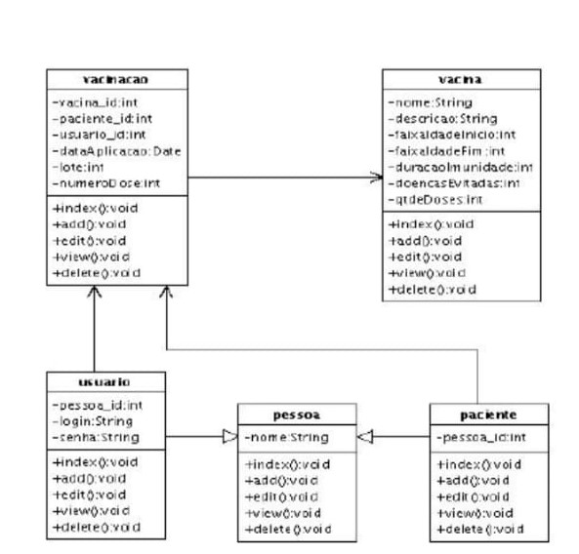

# **Use Case Diagram**

# 

# **Activity Diagram**

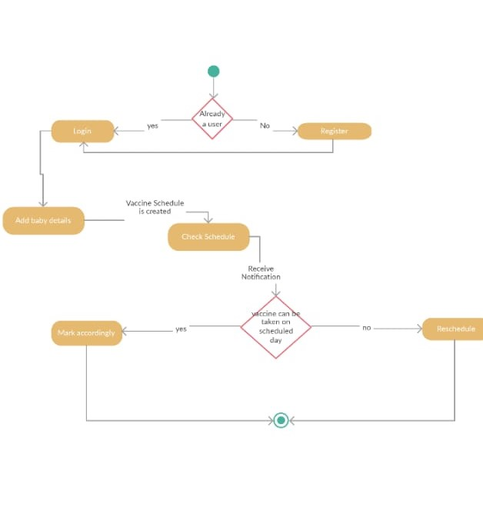

# **Sequence Diagram**

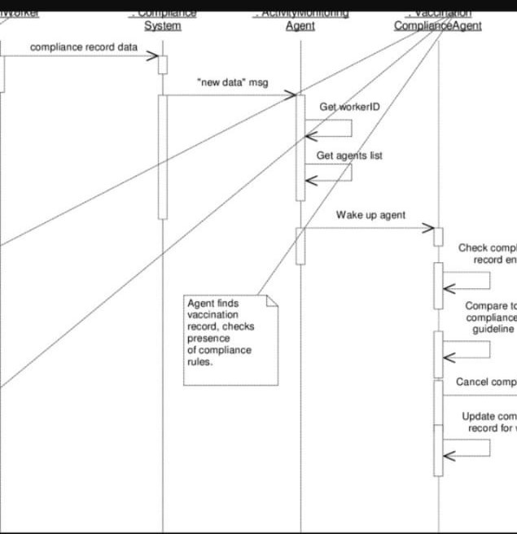

# **Deployment Diagram**

APPLICATION

DATABASE

Vaccination tracking system

User3

USER2

USER1

# **CHAPTER 4. DATA DICTIONARY**

**USER TABEL**

|  |  |  |  |
| --- | --- | --- | --- |
| **Field** | **Data type** | **Size** | **Constraint/Details** |
| U name | Text | 10 | User name |
| Mo no | integer | 10 | U mobile no |
| age | integer | 10 | User age |
| Gender | Text | 10 | User gender |
| Upload document | file | - | User identification |

**Nearest vaccine center**

|  |  |  |  |
| --- | --- | --- | --- |
| **Field** | **Data type** | **Size** | **Constraint/Details** |
| location | text | 20 | User location |
| Nearest vaccine center | text | 30 | Number of vaccine centers |

Covid information

|  |  |  |  |
| --- | --- | --- | --- |
| **Field** | **Data type** | **Size** | **Constraint/Details** |
| +ve patients | text | 10 | Information about positive patients |
| Vaccinate  people | integer | 10 | Number of vaccinate people |

# **Chapter 5. Screens**

# **Home page:-**

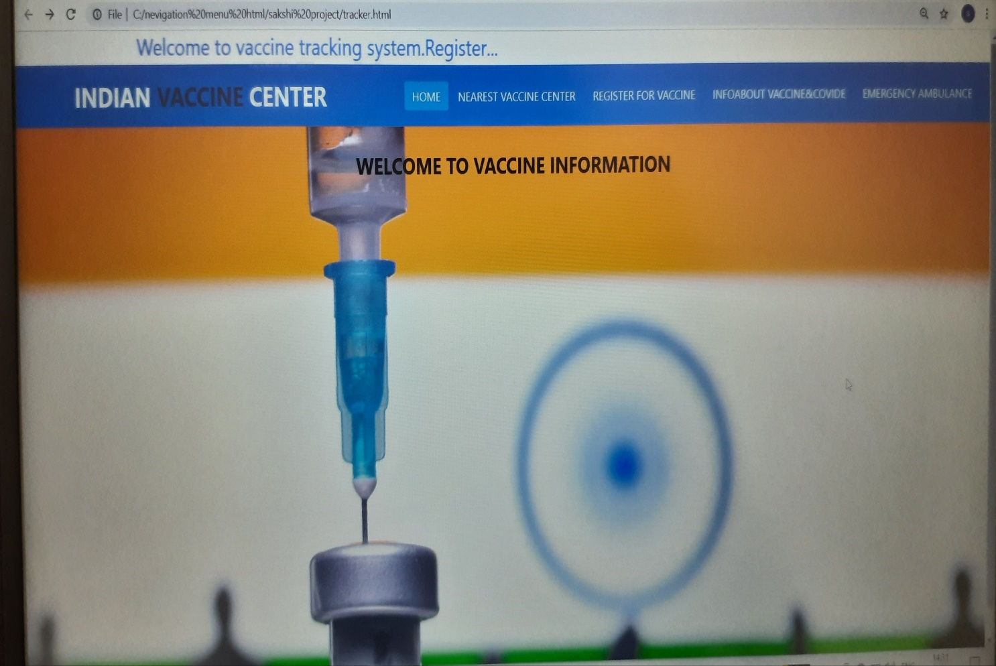

# **Registration page:**

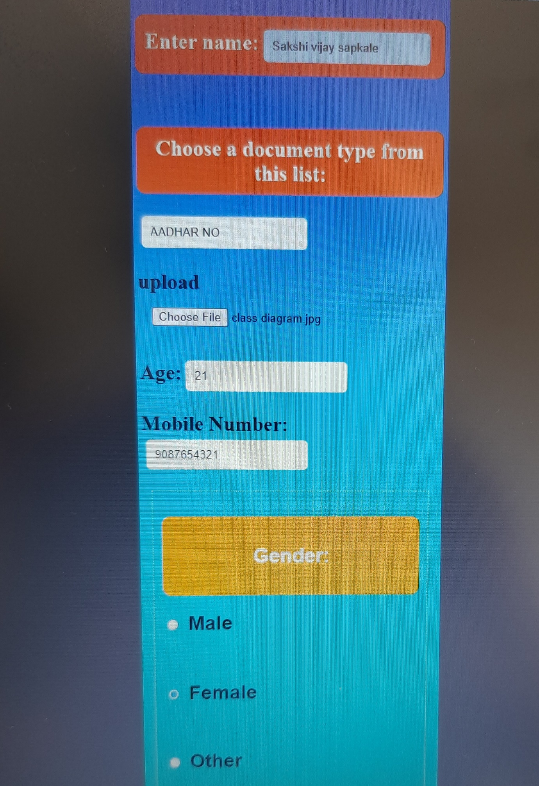

# **Registered successfully:**

# 

# **Find my nearest vaccine center:**

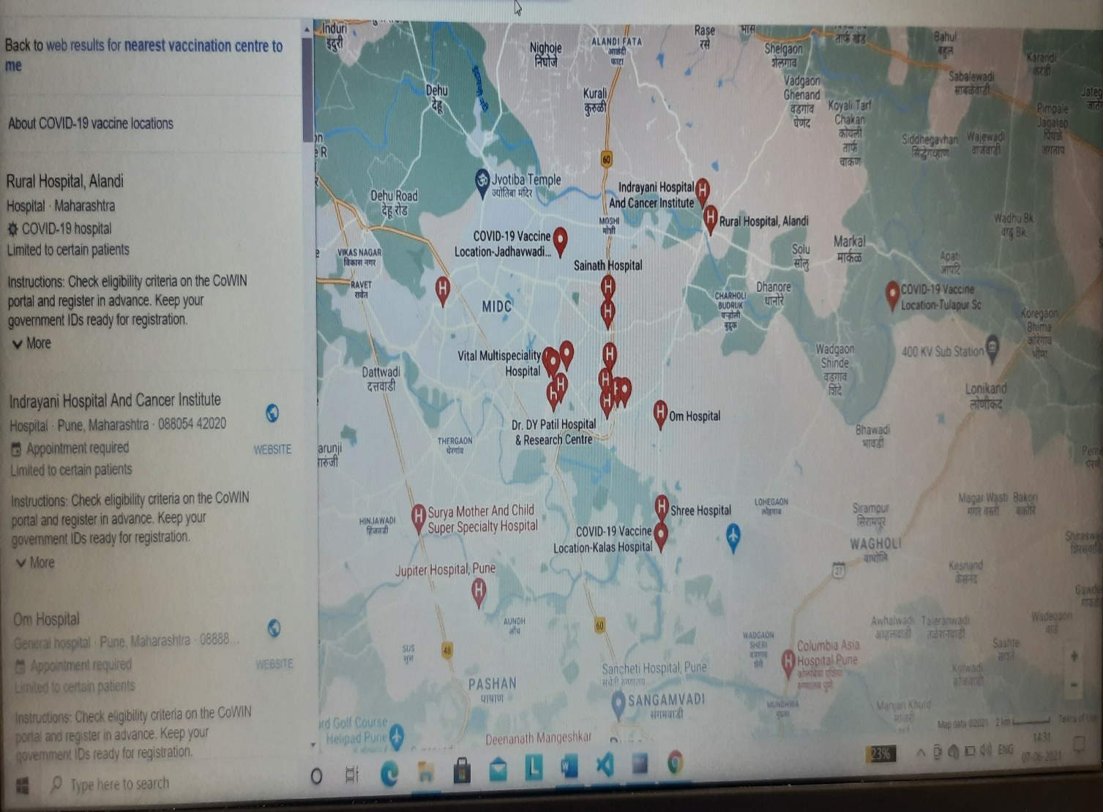

# **Information about covid-19:-**

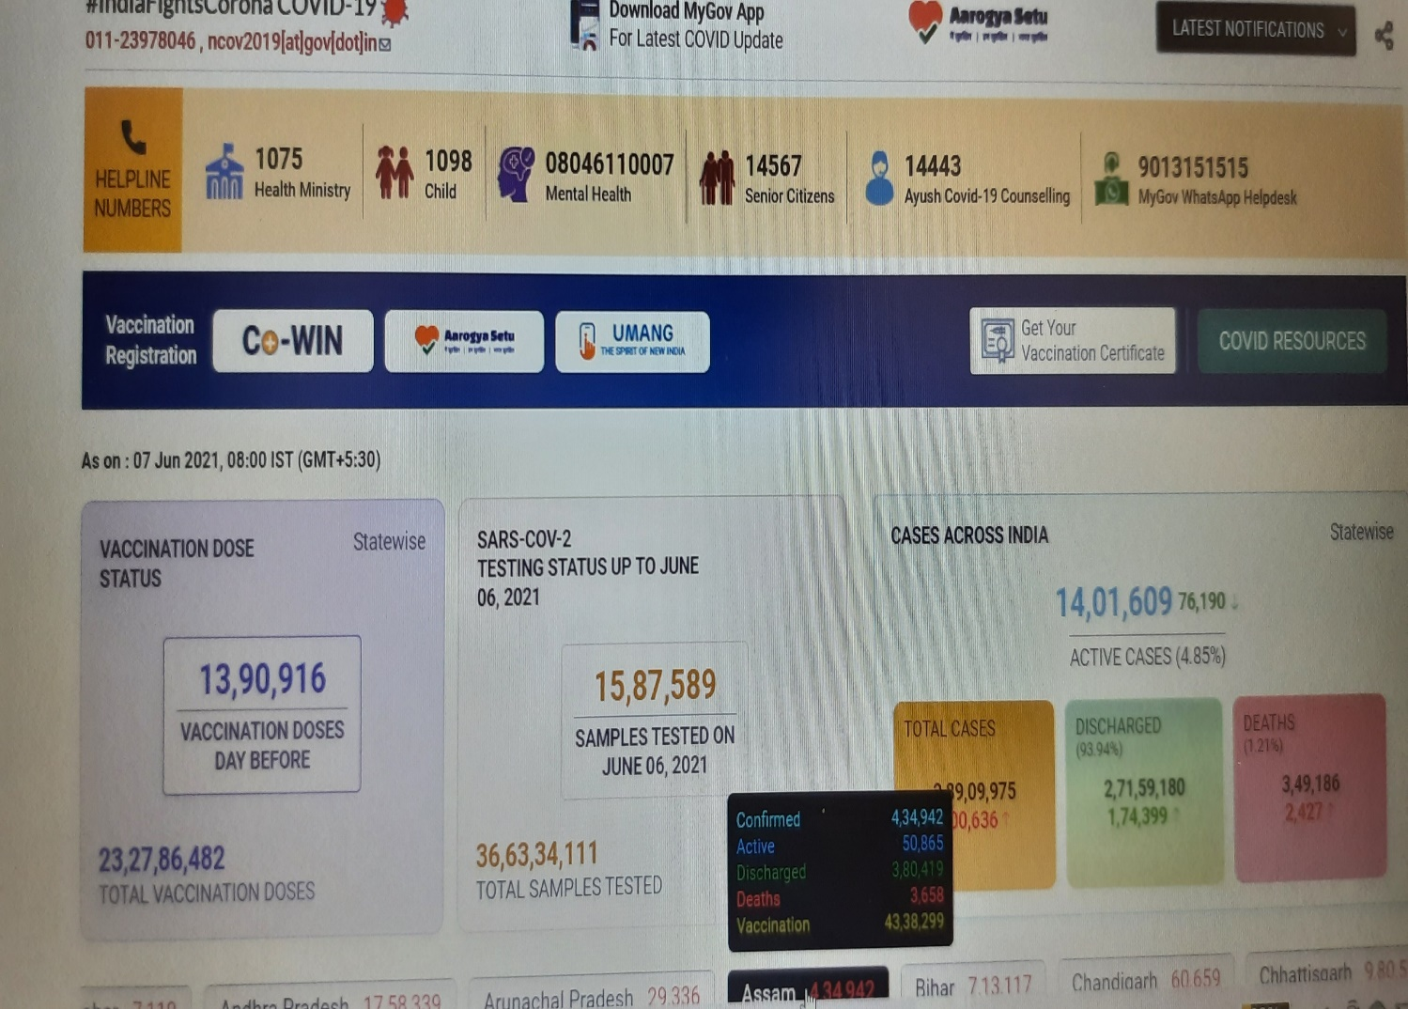

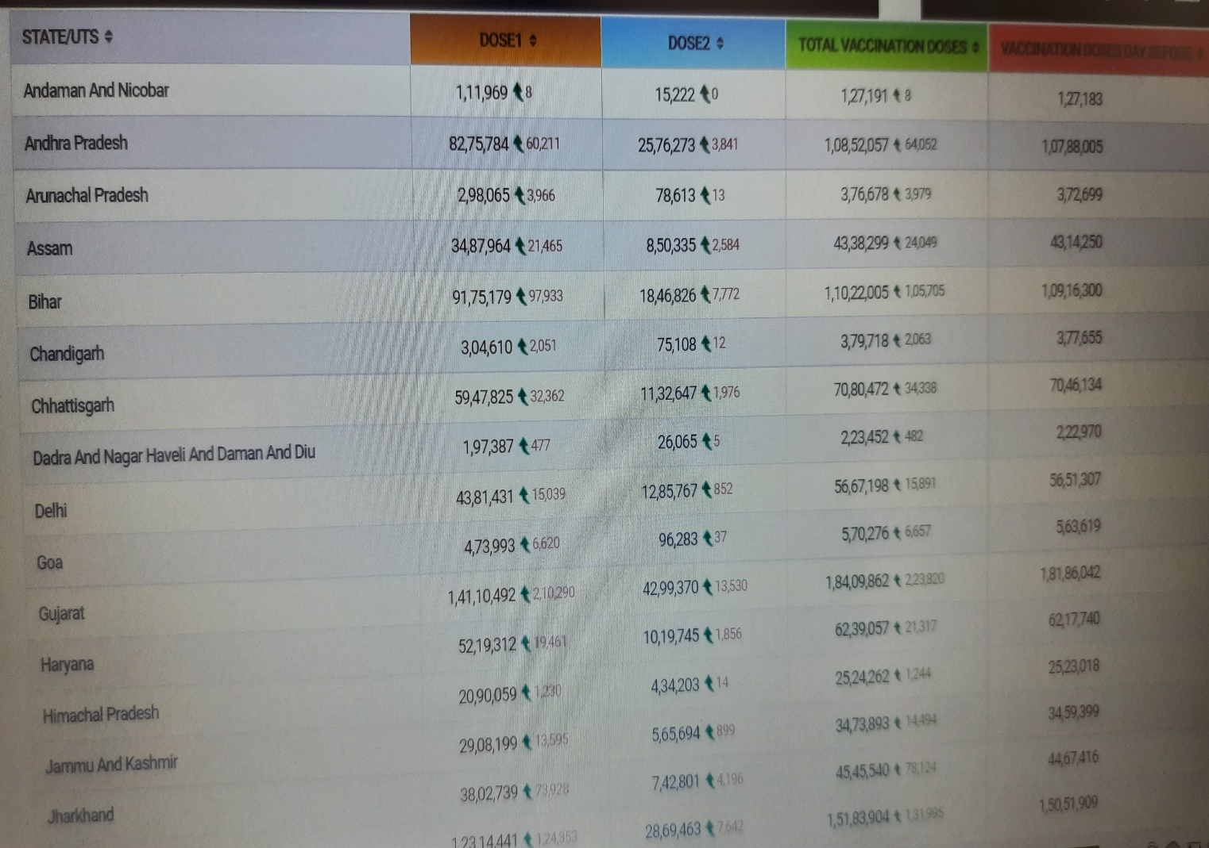

# **For emergency ambulance numbers:**

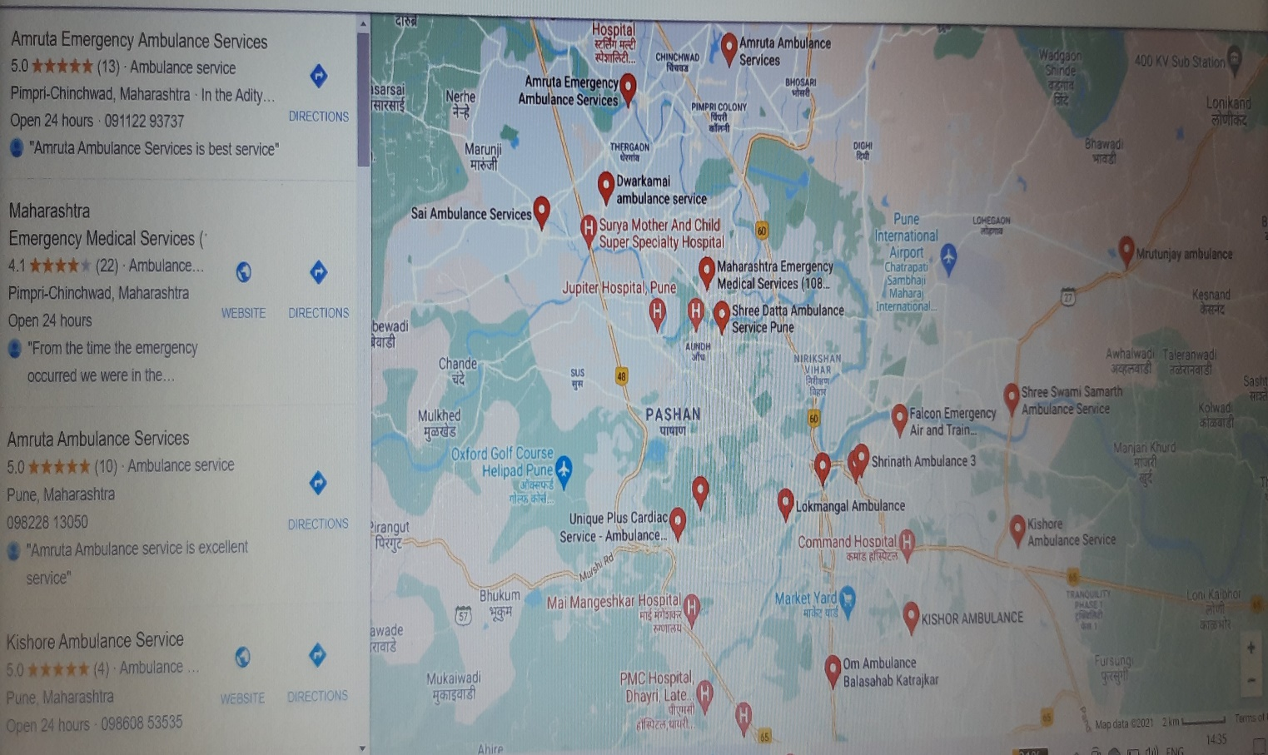

**Chapter 6. Limitations and Future Enhancement**

**Limitation of Vaccine Tracking System**

**HARDWARE LIMITATIONS:**

The main limitation of project lies in the fact that it requires SQL server as back end. The hardware needed to run a database costs a little bit more than a normal desktop PC. However, the falling prices have already made them an easy buy. So the choice of hardware becomes a bit tricky. Works on a stand-alone machine only:- The application software been developed is not optimized to work on any Network Operating System (NOS). The software is optimized for standalone application only. Fixed criterion for running the software :- The search option under ‘Report’ has a fixed criterion for searching the required fields.

**Front End Tool**

HTML has been chosen as front-end tool for developing the software because of its following important features:

One of the many significant is that HTML provides support for easily creating the user interface to your application. This is accomplished within the HTML and PHP Integrated Development Environment, in which a mouse is used to “draw” your application and keyboard for typing in the code that is to be executed.

**Back End Tool**

SQL Server is with the help of php chosen as back end tool for the development of the project because of following powerful capabilities:

• Retrieving information from the SQl Server

• Managing data sharing   
• Updating the database

• Further, the faculty can upload the document for user identification.

• Online information also provided to user to aware about the current situation.

• ambulance number is also provided.

# **Chapter 7. Bibliography**

1. [www.google.com](http://www.google.com)

2. [www.youtube.com](http://www.youtube.com)

5. Nirali Prakashan web technology and advance web technology Book